Red
Amber
Green

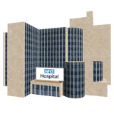
Hospital Passport for people with Learning Disabilities

Please take this Hospital Passport if you have to go into hospital.
This Hospital Passport gives staff looking after you important information about you. Please ask staff to read it.
You can contact the Learning Disability Liaison Team when you are coming into the Hospital.

Telephone: 01271 314171

Email: rduh.learningdisability-northern@nhs.net

Hospital Passport updated on: (Month) ……… (Year) 20......

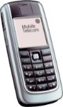



This Hospital Passport was developed by the Learning Disability Liaison Team and Derriford User Group (DUG) within University Hospitals Plymouth NHS Trust. This is based on the original work created by the Gloucester Partnership NHS Trust & Royal Cornwall Hospitals NHS Trust. Images ©Photosymbols and ©Shutterstock. July 2021.

RED
Things you MUST know about me
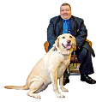  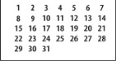         |  | Name: NHS No:  I like to be known as:  Address: Tel No:  Date of Birth: GP:  Please check that I fully understand my choices around what will happen if I do or don’t have treatment.  I am the only carer for a person or a Pet: Yes / No  Details:
  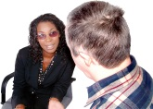  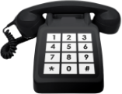 |  | Next of Kin: Tel No:  Relationship:  Care Provider: Tel No:  Key worker/Main carer: Tel No:  Known to Social Services? Yes / No  Contact name: Tel No:  Who I would like you to contact first:  Tel No:
 |  | Religion/Religious requests:
     |  | Allergies:  Current medical conditions:  End of Life plan in place: Yes / No If Yes, please supply a copy.  How I want difficult or bad news broken to me:  My preferred communication method to help me understand is:  Speaking / Signing / Pictures / Other:
This is my normal Baseline, and my NEWS2 Score is (if known)
Respirations | Saturations | Blood Pressure | Heart rate | Temperature

Amber
Things you NEED know about me
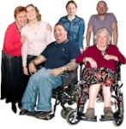 |  |  | For me to feel safe – e.g. bed rails, people to support me, what I understand?
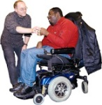 |  |  | Level of support – e.g. who needs to stay with me and how often?
 |  |  | If I am anxious it helps if you…
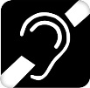  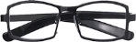 |  |  | Seeing/Hearing – e.g. glasses, hearing aids?
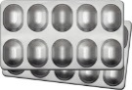 |  |  | How I take medication – e.g. oral / syrup / peg.
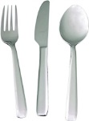 |  |  | Eating (swallowing) – e.g. dentures, food cut up, choking, eating aids, help with feeding, peg.
 |  |  | Drinking (swallowing) – e.g. Small amounts, choking, what I like to drink, what I drink from.
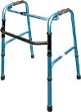 |  |  | How I get around – e.g. mobile, aids, hoist transfer.
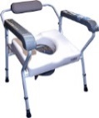 |  |  | Going to the toilet – e.g. independent, pads, catheter, aids needed.
 |  |  | Personal care – e.g. dressing, washing, etc.
 |  |  | Sleeping – e.g. sleep pattern, sleep routine, sleep system, posture?

Green
Things you SHOULD know about me
 | Think about – what upsets you, what makes you happy, things you like to do such as watching TV, reading and listening to music. How do you want people to talk to you (don’t shout). Food likes, dislikes, physical touch, special needs, routines, things that keep you safe.
 |   Things I like |  |  |   Things I DO NOT like

 |  |  | PAIN
 | 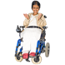       |  | What I look like when I am WELL: (What does my face, skin, eyes look like?)  How do I sound when I am WELL: (What do I sound like, how do I communicate?)  Body movements when I am WELL: (What does my body look like?)  Other things to know, when I am WELL:
 |   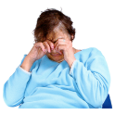  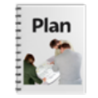    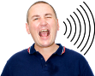 |  | What I look like when I am UNWELL/in PAIN: (What does my face, skin, eyes look like?)  How do I sound when I am UNWELL/in PAIN: (What do I sound like, how do I communicate?)  Body movements when I am UNWELL/in PAIN: (What does my body look like?)  Other things to know, when I am UNWELL/in PAIN:  What you need to do FIRST when I am UNWELL/in PAIN:

