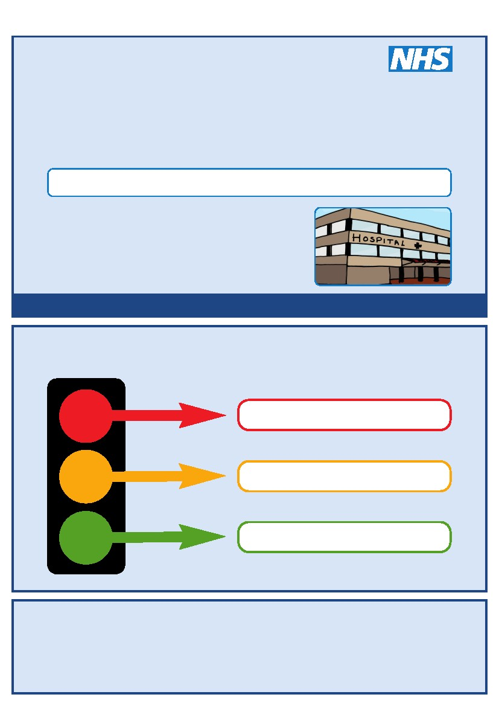


For people with Learning Disabilities coming into hospital

My name is:
I like to be called:
If I have to go to hospital this book needs to
go with me, it gives hospital staff important
Information about me.

This is my
Hospital Passport
It needs to hang on the end of my bed and a
copy should be put in my notes.
This passport belongs to me. Please return it when I am discharged.
Nursing and medical staff please look at my passport
before you do any interventions with me.
Things you must know about me
Things that are important to me
My likes and dislikes
If I am assessed as lacking the capacity to consent to my treatment the following people must be involved in best interest’s decision making
Name Relationship Contact Details
Name Relationship Contact Details
Name Relationship Contact Details
Name Relationship Contact Details

Mental Capacity Act 2005
My Photo
Things you must know about me
Name:
Likes to be known as:
NHS number:
Date of Birth:
Address:
Tel No:
How I communicate – e.g. What language I speak / Equipment / Signs / Photos / Symbols I use:

Family contact person, carer or other support:

Relationship e.g. Mum, Dad, Home Manager, Support Worker:
Address:
Tel No:
My support needs and who gives me the most support:

My carer speaks:
Date completed
By
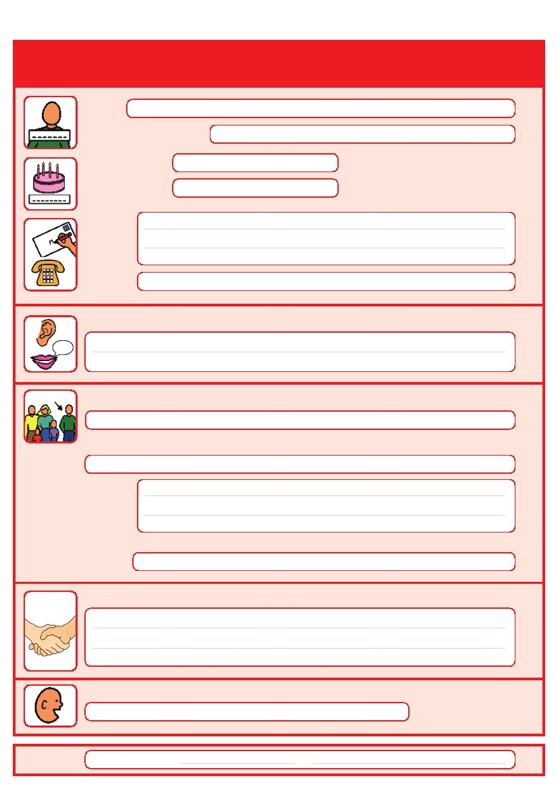
Things you must know about me
Religion:
Religious/Spiritual needs:
Ethnicity:
GP:
Address:

Tel No:

Other services/professionals involved with me:
Allergies:

Medical Interventions – how to take my blood, give injections, BP etc.

Heart:
Breathing problems:
Risk of choking, Dysphagia (eating, drinking and swallowing):
Date completed
By

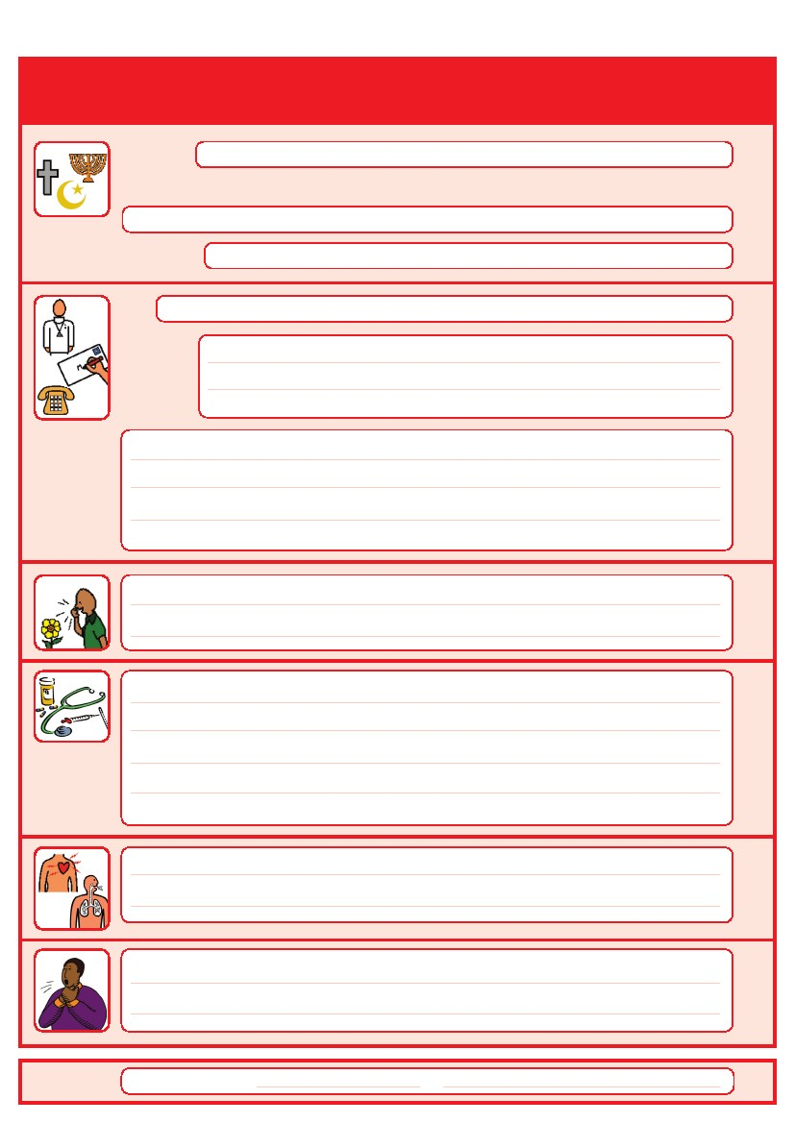
Things you must know about me
Current medication:

My medical history and treatment plan:

Operations and illnesses I have had:
What to do if I am anxious worried or upset:

Date completed
By

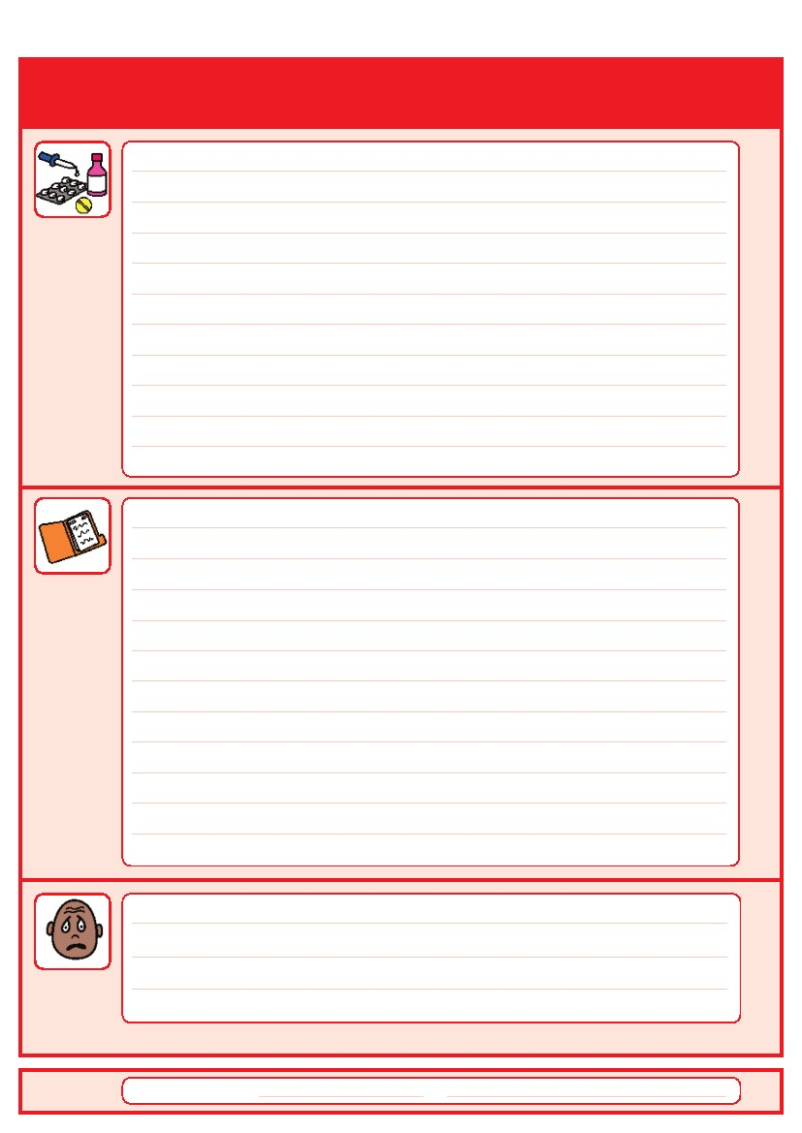
Things that are important to me
How to communicate with me (such as speed of speaking, signing, pictures, photos, symbols)

How I take medication: (whole tablets, crushed tablets, injections, syrup)

How you know I am in pain: –
Moving around: (Posture in bed, walking aids)

Personal care: (Dressing, washing, brushing teeth,)

Date completed
By

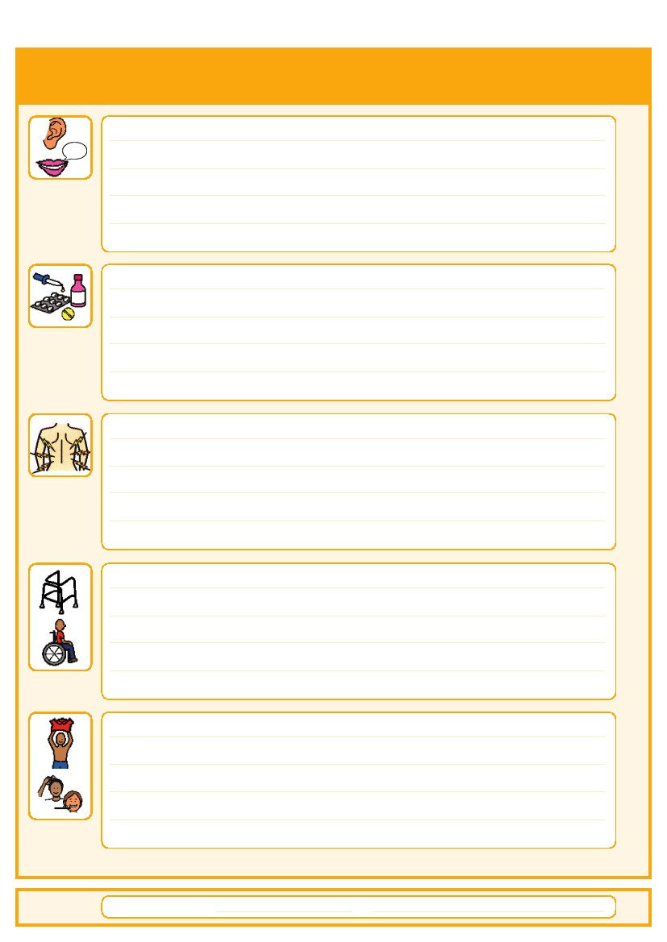
Things that are important to me
Seeing/Hearing/ smelling: (Problems with sight, smell or hearing)

How I eat: (Food cut up, pureed, risk of choking, help with eating)

How I drink: (Drink small amounts, thickened fluids)

How I keep safe: (Bed rails, support with challenging behaviour)

How I use the toilet: (Continence aids, help to get to toilet)

Sleeping: (Sleep pattern/routine)

Date completed
By

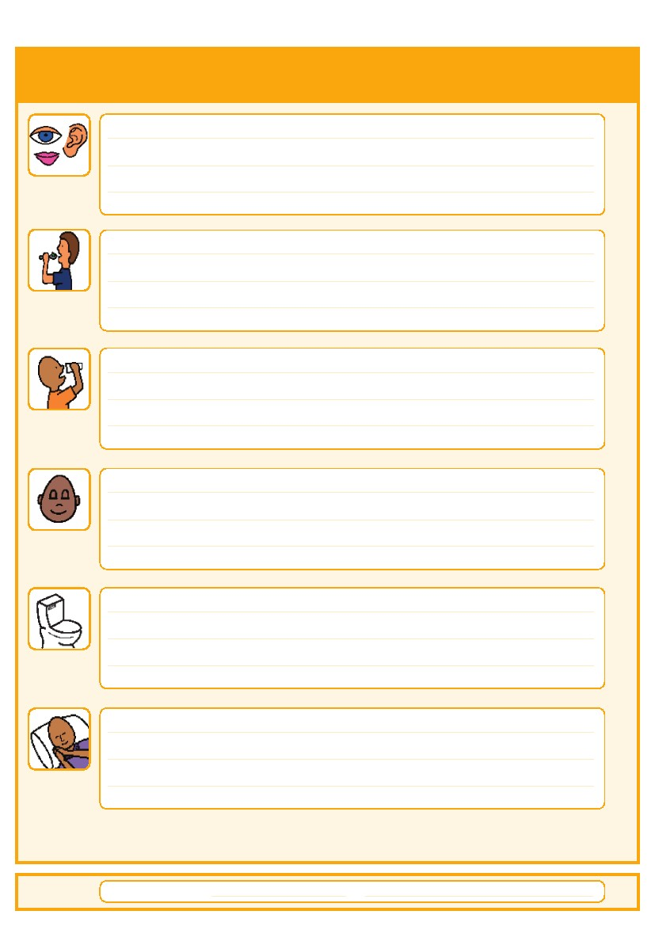

Things that are important to me

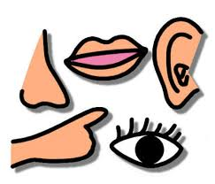

My Sensory Reactions | Under sensitive | Average | Over sensitive
Light
Noise
Touch/Pain
Smell
Taste
Spatial awareness
Balance

Date Completed By

Difficulties
Yes No
Busy/noisy places are stressful
Being with others is tiring
Bright / Flickering lights upset me
Do not like eating in company
I can’t read body language
I don’t understand metaphors (Takes things literally)
I am anxious with strangers
I feel lonely at times
I need time to plan what I am doing
Changes of plan make me anxious
I get confused by too much information

Abilities
Average Poor
Balance
Speed of responding
Social Conversation
Co-ordination
Short term memory
Time management
Concentration
Multi-tasking
Sense of direction
Sleep
Others

My likes and dislikes
Likes: for example - what makes me happy, things I like to do (Watching TV, reading, music, routines).
Dislikes: for example - don’t shout, food I don’t like, physical touch, loud noises, bright lights.
Things I like
Please do this:
Things I don’t like
Don’t do this:

Date completed
By

Things I like
Please do this:

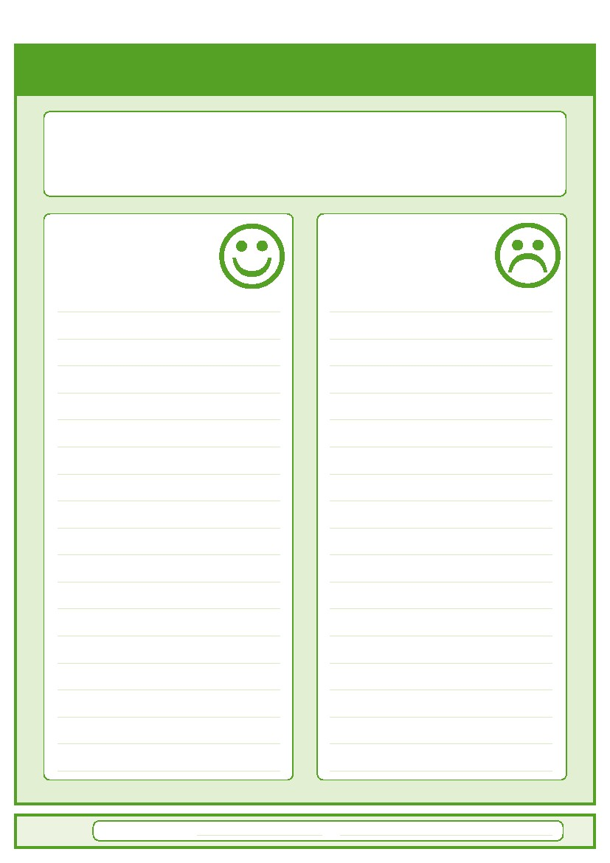

Notes, Annual Health Checks & Websites

TEHNNS

Examples include minimal waiting times, first on the outpatients clinic or theatre list and communications needs. The hospital tries to consider all requests but they should be based on needs, not wants.
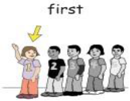
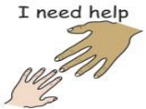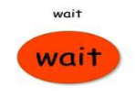

Parent/Carers
Our vision is: 
- That we listen to and communicate with carers, families and friends.
- That we support carers and patients to maintain their wellbeing and be treated with the dignity they deserve.
- That carers, families and friends are valued and recognised as equal partners in individual care
If you need any support your meet your needs as a carer then please use this space to tell us.

REASONABLE ADJUSTMENTS
A ‘reasonable adjustment’ is a change that has been made to a service so that people with
disabilities can use them like anyone else

Name/Organisation Job Title/Role Contact Details
Who else is involved with me?
Please give details of everyone who is involved with you from education, health and social services

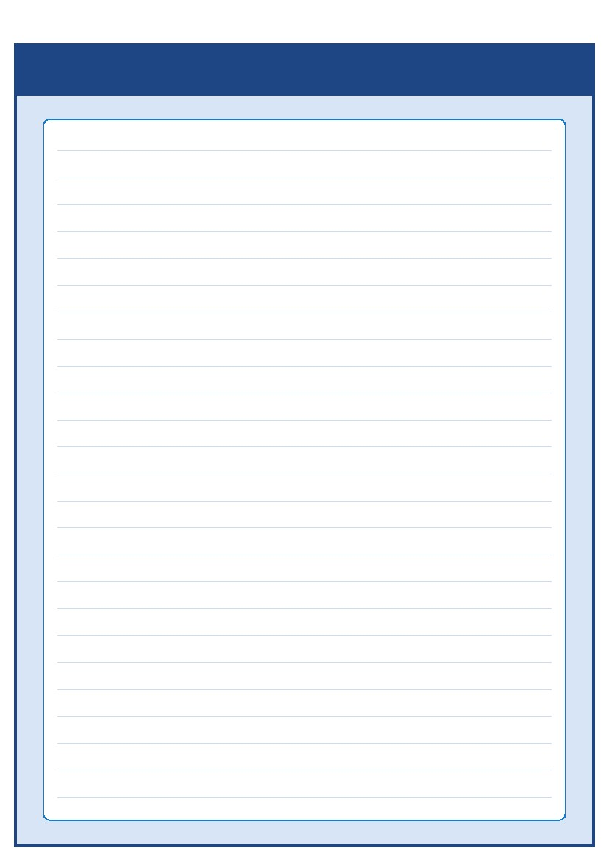

Annual Health Checks 14 Years + – Understand your health improve your life
Everybody with an intellectual (Learning) Disability should see their GP every year for an annual health check
Annual health checks should cover - My Thoughts / Feelings & Mood ; Eyes ; Ears ; Mouth & Teeth ;Throat & Swallowing ; Blood Pressure ; Skin ; Sexual Health ; Bones & Joints ; Feet & Toes ; Stomach & Bowels ; Chest & Lungs
What about checking …… Epilepsy ; Diabetes ; Blood Test ; Urine Test ; Pain Any other health problems
Useful websites –Providing Health information made easy to understand
www.mencap.org.uk/gettingitright Getting it right when treating people with a Learning Disability
www.bild.org.uk British Institute of Learning Disabilities help develop the organisations who provide services, and the people who give support
www.booksbeyondwords.co.uk stories in pictures to help people with learning and communication difficulties explore and understand their own experiences
www.easyhealth.org.uk Accessible Health information
www.intellectualdisability.info Health information for Health professionals
Notes:


The Hospital Passport is based on original work by Gloucester Partnership NHS Trust, South West London Hospital Access to Acute Group, Barking Havering and Redbridge University Hospitals and University Hospital Bristol.

Redesigned by the Children’s Learning Disability Health Team for Torbay and South Devon NHS
NHS Foundation Trust

Teams that can help in the community
Provide health support for children with learning disabilities and their families in the Community.

The team is made up of:
Community Learning Disability Nurses
Assistant Practitioner
Specialist Support worker

To find out more you can contact them at;

First floor,
St Edmunds,
Victoria Park road,
Plainmoor,
Torquay,
TQ1 3QH

Tel: 01803 656570
Email: cldt.torbay@nhs.net
Facebook page: CLDTTorbay

You may wish to discuss support via the team with your GP

Community Children’s Learning Disability Health Team(CLDT)
Please contact your local community Learning Disability Health Team
if you have any questions about the passport

